**LAB TASK-2**

**CODE-**

import numpy as np

import pandas as pd

from sklearn.linear_model import LinearRegression

from sklearn.model_selection import train_test_split

def mse(y_t,y_pre):

su=0

for i in range(len(y_t)):

su=su+(y_t[i]-y_pre[i])**2

return(su/len(y_t))

def test_train(x,y,tes):

x_train,x_test,y_train,y_test=train_test_split(x,y,test_size=tes,random_state=1)

reglin=LinearRegression()

reglin.fit(x_train,y_train)

y_pred=reglin.predict(x_test)

print('rmse',(mse(list(y_test),list(y_pred)))**(0.5))

print('mse',(mse(list(y_test),list(y_pred))))

#data_link="https://www.kaggle.com/karthickveerakumar/salary-data-simple-linear-regression"

data=pd.read_csv(data_link)

features=['YearsExperience']

x=data[features]

y=data.Salary

print('\n16BIS0137 \n T.DHIRAJ\n')

print('train : 50%')

test_train(x,y,0.5)

print('\n')

print('train : 70%')

test_train(x,y,0.3)

print('\n')

print('train : 80%')

test_train(x,y,0.2)

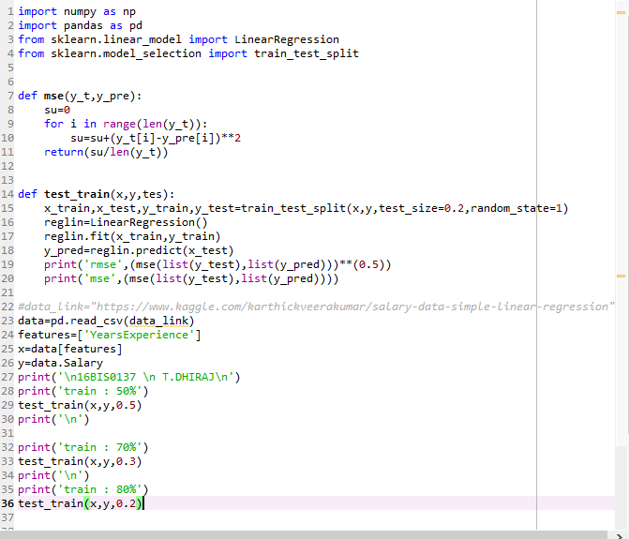

**OUTPUT**

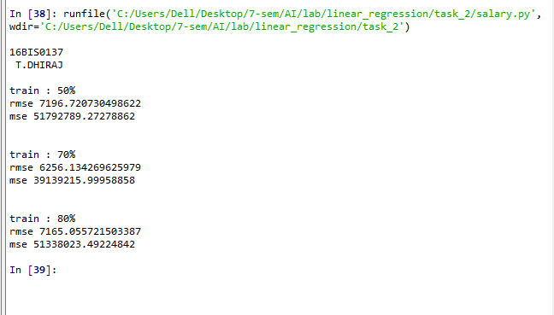

train : 50%

rmse 7196.720730498622

mse 51792789.27278862

train : 70%

rmse 6256.134269625979

mse 39139215.99958858

train : 80%

rmse 7165.055721503387

mse 51338023.49224842